Name - Mohammad Adnan Ali
Registration No. - BL.SC.P2CSE25010

LAB ASSIGNMENT 5

Taxi Route Optimization Using Q-Learning

1. Title
Taxi Route Optimization Using Q-Learning

2. Objective
The objective of this experiment is to train a Reinforcement Learning agent to navigate a taxi environment, pick up a passenger, and drop the passenger at the required destination efficiently.

3. Application Description
Taxi Route Optimization is a Reinforcement Learning problem where a taxi agent must learn how to navigate through a grid environment.
The agent learns through trial and error. It receives rewards for successfully completing the task and penalties for unnecessary movements or illegal actions.
The goal is to learn a policy that allows the taxi to successfully transport passengers while minimizing unnecessary movements.

4. RL Problem Formulation
RL Component | Description
Agent | Taxi
Environment | Taxi-v4 environment
State Space | 500 discrete states
Action Space | 6 actions
Actions | South, North, East, West, Pickup, Drop-off
Reward | +20 for successful drop-off, −1 per movement, −10 for illegal pickup/drop-off
Terminal Condition | Passenger is successfully dropped at the destination
The Taxi-v4 environment and 500-state/6-action configuration were used in the implementation.

5. Algorithm Used

Q-Learning
Q-Learning is a model-free Reinforcement Learning algorithm. It learns the expected value of taking an action in a particular state.
The agent maintains a Q-table containing values for each state-action pair.
The Q-value is updated after every action using the reward received and the estimated future reward.

Training Parameters
Parameter | Value
Training Episodes | 5,000
Learning Rate (α) | 0.1
Discount Factor (γ) | 0.99
Initial Epsilon | 1.0
Minimum Epsilon | 0.01
Epsilon Decay | 0.995

6. Implementation
The implementation was performed using:
- Programming Language: Python
- Environment: Gymnasium
- Algorithm: Q-Learning
- Q-table size: 500 × 6
The Q-table was initialized with zeros and updated during each training episode using the Q-Learning update rule.

7. Training Details
The agent was trained for 5,000 episodes.
An epsilon-greedy strategy was used for action selection. At the beginning of training, the agent explored the environment extensively. As training progressed, the exploration rate was gradually reduced, allowing the agent to use the learned Q-values more frequently.

8. Results and Learning Curve
The Reward vs Episodes learning curve shows that the reward initially starts at a low value and gradually improves as training progresses.
After sufficient training, the moving-average reward becomes relatively stable, indicating that the agent has learned an effective policy.
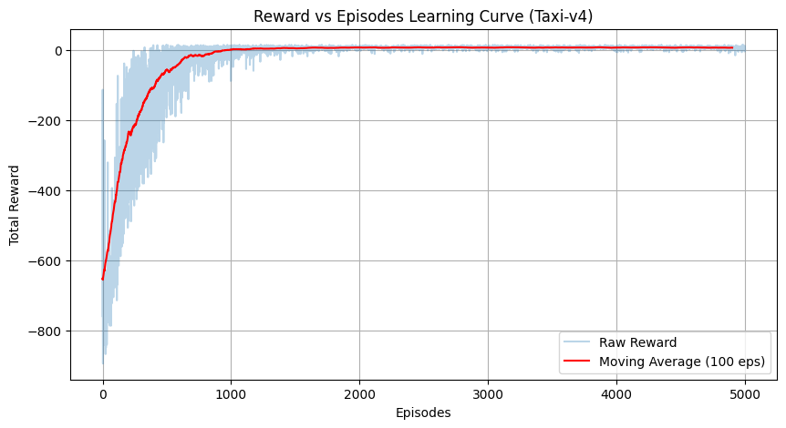
Figure 1. Reward vs Episodes learning curve for the Q-Learning agent.

9. Performance Analysis
The trained agent was evaluated for 100 test episodes.
Performance Measure | Result
Test Episodes | 100
Average Reward | 7.89
Average Steps | 13.11
Success Rate | 100%
Best Reward | 15
The agent achieved a 100% task completion rate during the 100 test episodes. The average number of steps was 13.11, while the average reward was 7.89.
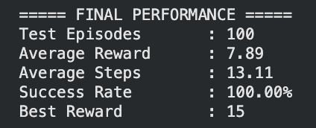

10. Observations
The following observations were made:
- The agent initially performed poorly because it was exploring different actions.
- Performance improved as the Q-table was updated through training.
- The learning curve shows clear improvement during training.
- The exploration rate gradually decreased, allowing the agent to exploit learned actions.
- During testing, the agent achieved a 100% success rate.
- The trained agent successfully learned how to pick up and drop off passengers.

11. Conclusion
The Taxi Route Optimization problem was successfully formulated as a Reinforcement Learning problem and solved using Q-Learning.
The trained agent learned an effective policy through interaction with the Taxi-v4 environment. After 5,000 training episodes, the agent achieved a 100% success rate over 100 test episodes, demonstrating that Q-Learning can effectively learn the taxi navigation task.

12. References
- Gymnasium Documentation — Taxi Environment.
- Sutton, R. S. and Barto, A. G., Reinforcement Learning: An Introduction.
- Python Documentation.

